ROC’D
Rapid Online Course Development Project



Time Management Instructional Module:
Creating an Assignment
Creating and Assessment
Creating an Electronic Calendar

Designed by:
Erin Gunter
Kevin Wicker

MIT 500
Dr. Moallem
12/10/2008
Table of Contents

Report One
Section One 3
Theory Assumptions and Rationale 3
Learner Analysis 5
Context Analysis 9
Section Two
Needs Analysis 11
Instructional Goals 12
Section Three
Task Analysis 12

Report Two
Section One
Instructional Strategies 13
Goals 15
Performance Objectives 15
Assessment Tasks 15

Report Three
Section One
One-on-One Evaluation Results 27
Small Group Evaluation Results 30
Section Two
Planning Log 32

Appendices

Task Analysis (Appendix A) 36
Assessment Book (Appendix B) 37
One-on-One Evaluation Results (Appendix C) 53
Small Group Evaluation Results (Appendix D) 54
Report I

Section I
Part One:
Theoretical Assumptions
Mayer’s (SOI) Model for Designing Instruction for Constructivist Learning
Mayer’s model for Designing Instruction for Constructivist Learning focuses on how to present information to the learner. The main assumptions and theoretical foundations of Mayer’s model are: knowledge construction is not reliant on behavioral activity and the learner can construct their own knowledge. This constructivist model helps learners apply previous knowledge to solve new problems. Mayer states that there are three different views of learning: learning by response strengthening (strengthens or weakens associations between a stimulus and the response), learning as knowledge acquisition (places new knowledge in long-term memory), and knowledge construction (learner actively constructs knowledge in the working memory). Mayer’s SOI model uses the third view on learning. So, the instructional designer can develop an environment that requires the learner to make sense of information that is presented to them. Mayer proposes that the environmental design for constructivist learning depends on three prerequisites. The prerequisites are skills of selecting, organizing and integrating. This is why the model is called the SOI model. Learners have to have the skills that allow them to first select the relevant information to process further. Then they need to organize the information by making mental representations in their working memory. Lastly, they need to be able to integrate new incoming knowledge with existing knowledge. A main belief of this model is that when new knowledge is coming in during a learning situation, learners can build on prior knowledge to construct mental models of the information. The other two prerequisites are meta-skills which are the processes for self-regulation and will, which is the attitude and motivation behind the learning process. Mayer proposes that the learner will be able to retain the knowledge and then transfer the knowledge to a new situation if all three prerequisites exist prior to new knowledge construction.
Using Reigeluth’s framework to understand Mayer’s model is helpful in determining whether or not it is appropriate for our instructional module. The type of learning that occurs is constructivist learning learners construct their knowledge by using prior knowledge to understand materials that are presented to them. For, example learners will build on their prior knowledge of making assignments, assessments, and calendars to make similar ones using a learning management system like Blackboard vista. Learners are able to meaningfully interact with materials by selecting, organizing, and integrating information and the knowledge is represented in working memory and is then transferred to long term memory. The learner is in control of their learning and the instructional designer provides guidance and structure through the use of the materials presented to the learner. The focus of the learning is central to a specific topic or concept that the instruction is designed to teach. Grouping for learning is individual because each learner constructs their own knowledge. The primary interaction for learning is student working with the specific materials that are provided. The support for learning is mainly cognitive.
By breaking down the model using the Reigeluth framework, it is easy to see how Mayer’s model is useful when designing and developing our instructional model. There are three main reasons why we think Mayer’s SOI model is appropriate for our specific instructional model. The first reason is that using the selecting, organizing, and integrating instructional strategies provides relevant methods for multimedia instruction. Using Mayer’s model for Designing Instruction for Constructivist Learning in collaboration with Mayer’s Cognitive Multimedia Learning Theory, we will have a plethora of tools, principles, and knowledge at our disposal in order to design our instructional module properly. Secondly, this model emphasizes the learner’s ability to apply knowledge. The final reason why Mayer’s model will be appropriate for our module is that the learners that will be using our module will have the proper prerequisites for problem-solving transfer. They all have appropriate cognitive processes, self-regulatory processes, and a positive attitude towards completing the procedures required to make assignments, assessments, and an electronic calendar using a LMS. Although they may be a little hesitant to change, they do have the desire to learn the material presented in our module.
When implementing Mayer’s model, we must first look at all the components and sub-components. As we have already stated, the main components of this model are selecting relevant information, organizing the information for the learner, and integrating the material. The sub-components of this model are the techniques used by each method. The first component is selecting relevant information; this can be done by highlighting all the pertinent information for the learner with the use of headings, repetition, captions, outlines, etc. For our module, an instructional video will be made to outline the procedural steps needed to input due dates into an electronic calendar using a learning management system. Relevant information will be highlighted by including concise captions that reiterate and summarize the procedural steps demonstrated in the instructional video. The visuals used in the instructional video will also depict specific procedural steps that need to be taken and they summarize the procedure. By having both words and pictures that are clear and concise, Mayer proposes that the learner will be able to select the relevant information because extraneous information has been eliminated. Adjunct questions and learning objectives will also help the learner focus on the relevant information. Examples from our module would be: (Objective) Learners will be able to demonstrate the procedure of inputting assignment due dates, from their list of scheduled assignment dates, into an electronic calendar using a learning management system. Adjunct question example: What purpose will an electronic calendar serve in a learning management system?
The next component of the model is organizing information. This organizes information by constructing both a pictorial mental model that matches the verbal mental model. For our module we are going to use the enumeration method to demonstrate the step by step actions needed to perform a task. For example: split up the steps needed to input due dates into the electronic calendar. Using this method, we will make an outline of the procedural steps so that the learner can check their work as they complete the task. This will limit the amount of mistakes made by the learner. Flowcharts will be used to provide a step by step sequential graphic representation of inputting due dates into the electronic calendar in the learning management system. Signal words and title clips will be used in the instructional video to further organize the information. The title clips will be used at the beginning and the end of a section to provide headings and outlines or flowcharts of information that will be covered in that section. For example: the heading could have the title, “How to input due dates in an electronic calendar using a learning management system.”
The last main component of Mayer’s SOI model is integrating the new incoming knowledge with previous knowledge. The different techniques of integrating technology that will be used for our module are advanced organizers, animation with narration, worked-out examples, and elaborative questions. Advanced organizers show cognitive steps involved in the procedural tasks that need to be completed. For example, the learner will be provided with examples of a completed electronic calendar that has been developed for a course. Then the learner will go through the steps of making an electronic calendar. The advanced organizer will use the learner’s prior knowledge of constructing a calendar and compare it to the procedure of constructing an electronic calendar using a learning management system. Animation with narration will be used in the instructional video, learners will be able to watch and listen to the procedures used to input due dates in an electronic calendar on a learning management system. Worked-out examples will provide the learner with screen shots of an electronic calendar used in a learning management system with due dates already input in the electronic calendar. Lastly, elaborative questions require the learner to integrate new knowledge with prior knowledge because it asks the learner to think of a different situation where the information can be applied. “Can you describe a similar situation where you would use an electronic calendar to help students with time management?” This is an example, of an elaborative question about electronic calendars in reference to our instructional module.

Part Two:

Learner Analysis
Information Categories | Data Sources | Learner Characteristics
Entry Behaviors | Interviews and Observations | Performance Setting:  Learners have little to no experience with online course development. Learners have experience with time management skills. Learners have experience with designing assignments, assessments, and calendars.  Learning Setting:  Learners have experience with computers.  Learners have experience with classroom course development.
Prior Knowledge of Topic Area | Interviews and Observations | Learners have experience with designing assignments, assessments, and calendars.  Learners have experience with time management skills.  Learners have experience with classroom course development.
Attitudes Toward Content | Interviews and Observations | The learners are hesitant to switch to an online course design.  The learners do not necessarily believe that an online learning environment is better than traditional face to face learning environment.  Therefore they consider the change difficult.
Attitudes Toward Potential Delivery System | Interviews and Observations | Learners believe that online course environments will benefit their students and promote a constructivist style of learning.  Learners understand the benefits of the visually appealing online learning environment.
Motivation for Instruction  (ARCS model) | Interviews and Observations | Learners have a positive attitude about learning how to convert their traditional class material to an online learning environment. The material presented in this module is interactive and informative and it will help learners to deliver instruction to their students in a new way. Learning with interactive materials will ensure that the learner is attentive. The learners believe that the material is relevant to their future success as online instructors. Learners are confident that they can master the material and effectively incorporate it into their courses in the future.
Education and Ability Levels | Interviews and Observations | Educational Abilities:  Learners are currently employed in the higher education field.  Learners have successfully taught at the higher education level.  Ability Levels:  Learners have a varying degree of ability with computer skills.  Learners have a varying degree of ability with constructivist course development.  Learners have a varying degree of ability with generating strategies for time management for their students.
General Learning Preferences | Interviews and Observations | Learners are experienced with a variety of learning formats.  Learners are used to being in control of the learning environment and their students.
General Group Characteristics  Heterogenity: Race, Gender, Culture  Age  Language  Special Needs  Overall Impressions | Interviews and Observations | Heterogeneity:  Learners come from various backgrounds. There is a mixture of different cultures, genders, and races.  Age:  Learners are all higher education professors. Learners’ age ranges between 24 - 65 years old.  Language:  Learners are all fluent in the English language.  Special Needs:  Learners do not have any special needs.  Overall Impressions:  Instruction will need to be easy to use, efficient, and effective.
Attitudes Toward Training Organization | Interviews | Learners have positive feelings about the organization developing the materials and about using the computers for developing online courses.  They believe this training will help them be more successful in online course development.  Learners believe this training will help them generate strategies that help their students manage their time, participation, and assignments.

Context Analysis
Information Categories | Data Sources | Learner Characteristics
Managerial/Supervisory Support | Interviews | Supervision of the learner is minimal.  Learners will receive materials, resources, and technical support.
Physical Aspects of Site | Observation | Facilities:  Learners will use their personal computers or a computer at the higher education site to access the training material.  Resources:  Online tutorial video and printed material.  Equipment:  These computers need to have download capabilities, Internet, access to the university server if accessing from a remote location and Adobe flash must be downloaded on the computers. The learners need a learning management system account on their computer.  Timing:  45 min. with materials and software.
Social Aspects of Site | Observation | Supervision:  As needed only for technical support.  Interaction:  Learners with materials and computer.  Others effectively use Skills:  The learners must possess minimal technological skills to complete module.
Relevance of Skills | Interviews and Observations | Meet the identified goal.

Section II
Needs Analysis and Instructional Goals
Needs Analysis was completed as a large group. The following is our portion of the needs analysis chart. We selected to focus on the goal that is in bold.
Topics | Needs | Goals | Method of Data Collections
Management | - Online course designers need to spell out their rules regarding assignment due dates and participation in their syllabi and direct students’ attention to course guidelines and policies.  - Online course designers need to be explicit about the participation rules. Students need to know how often they are expected to participate in online discussions to manage their time.  - Online course designers need to organize information in an easy-to-follow order to save time for students.  - Online course designers need to schedule regular office hours for students - even if those office hours are just times when they will definitely be online checking messages & let students know when those office hours are so they can either meet virtually or send urgent messages to during that time and get immediate response.  - Online course designers need to create a discussion board for questions and direct students to go there to ask their questions.  - Online course designers need to create an FAQ where students can check to see if their question was already asked and answered. | Learner will generate strategies for students to utilize within the course that helps students manage time, participation, and assignments. (Problem-Solving – Intellectual Skills)  Learners will demonstrate learning management system skills and its functions, utilization of course tools given to maximize the helpfulness of the course, and provide proper feedback opportunities, materials, resource to students. (Intellectual Skills and Verbal Information )  Learner will develop an online learning environment that is organized, easily navigational, and will help direct students to important information to promote meaningful learning outcomes.  (Intellectual Skills and Verbal Skills) | Learner and Instructor interviews  Online course review

Instructional Goals

Our main goal for our self-instructing module is:
Learners will generate strategies for students to utilize within an online course that will help students manage time (IS-PS)
The following are the sub-goals for our module:
Learners will create an assignment using a LMS (R)
Learners will create an assessment using a LMS (R)
Learners will create an electronic calendar using a LMS (R)

Section III
Task Analysis (Appendix A)

Follow this link to go to a GIF Format of the Task Analysis that is easier to see.
Report II

Instructional Strategies

Sequence of Instruction

The instruction for this learning module is broken down into three different Captivate videos. The purpose of this is to present the material in a way so that the learner can follow the instructions easily without be bombarded by information. Each video used in this module breaks down the main tasks into step-by-step procedures that will help the learner reach the main performance goal. The videos used in this module have built in tasks that require learner participation to complete the training module. Throughout the videos, learners are asked to complete simple tasks to demonstrate their understanding of the material. At the same time, the learner will have an assessment booklet that reviews the steps that they have completed within the module. This ensures that the learner has completed each step by filling out a checklist or answering assessment questions. The assessment book makes sure that they have learned the material that is being presented to them and requires the learner to check to whether or not they have missed a step. The sequence of module is designed to show the proper steps required to perform the task. Therefore, the module teaches the learner how to complete a procedure that has multiple steps. In the end, it is important that all steps are completed in order for the learner to be able to complete the task independently without the assistance of this learning module.

Informing the Learner of the Goal

The learner is presented with the main performance task at the beginning of the video and the end of the video. Also, the assessment book that accompanies the learning module videos presents the learner with the instructional goals that they are trying to achieve. While watching the video and using the assessment book, the learner can stop and review the learning goals and outcomes whenever they desire.

Attention of the Learner

The learner’s attention is held throughout the instructional videos because they require active learner participation. The learner also completes self-assessment checklists and review items to ensure knowledge acquisition.

Presenting the Problem

The learner is presented with the main problem at the beginning of the assessment book that accompanies the module videos. The learner will be provided with both the video and the assessment book at the beginning of the instruction. The videos are then used to provide step-by-step procedures to complete the tasks. The videos use narration, text, and visuals to show the learner how to resolve the problem. The assessment book also provides the learner with checklists and questions that assess the learner’s knowledge of the material that has been presented in the instructional videos.

Structure and Content of Instruction

Captivate videos are used to present new material and a PDF file is used to present the assessment book that accompanies the instructional videos. The videos all use Mayer’s instructional strategies such as: color, bold type, captions, highlights, repetition, consistency, animation with narration, worked-out examples, and motion.
Bold type, highlights, and color are used to help learners pick out relevant information. All of steps that require the learner to select information in Blackboard vista shell are demonstrated. Then highlights, captions, bold type, and color are used when the learner has to perform the similar tasks that they have just observed. For example, a caption shows up when the learner will be asked to select information in the instructional video. This way the student knows what the important information is and where to find it on the screen.
Repetition and consistency is used in the videos and the assessment book checklists and questions. Checklists are used to help the learner assess their performance and ability to complete the tasks in each instructional video. Repeating the types of assessment items helps the learner and provides a consistent way of assessing performance. Also, the same LMS system is used in all of the instructional modules to provide both consistency and repetition for the learner.
Animation with narration helps the learner hear and see the relevant information. The learner sees the procedures demonstrated in the video, and then the narration guides the learner when it is their turn to complete the same procedures. Worked-out examples are used at the beginning of each assessment book section. These worked-out examples provide the learner with a screen shot that depicts the final result of the instructional videos. For example, a screen shot of an electronic calendar will be presented before the learner starts to assess their performance when creating an electronic calendar. By seeing the worked-out example the students will be motivated to complete the module. Motion will also be used to gain and retain the learner’s attention. Using motion in the video and showing the motion of the mouse helps the learner follow along with the video. When the mouse moves to a specific place on the screen the learner knows that it is part of the procedure for completing the task.
Each task that needs to be completed is presented as a rule or concept. In the video, each rule and concept is demonstrated and the student is asked to complete a task within the module or complete an assessment item from the assessment book. Screenshots will be used to reinforce the rules and concepts and they will be used in the instructional videos and in the assessment book. They will be used to make sure that the learner knows what steps they are completing. A checklist will also be available to assess the learner’s knowledge of the information.
This module is designed to be self-instructional. The learner should be able to use the videos and assessment book to learn the new material. After the completion of the assessment book and the videos, the learner should be able perform the tasks independent of the module. Using the instructional strategies that Mayer developed in his model helps the designer develop an instructional module that gains and retains the learner’s attention. By doing this, the learner has a better chance of achieving problem-solving transfer. Therefore, the strategies used in this module are intended to provide the learner with methods that help them select relevant material, organize the material into a step-by-step procedure, and integrate their previous knowledge with the new information that they were learning
Teaching and Assessing the Terminal Objective
The terminal objective for this module is broken down into three instructional videos. This chunks the relevant information together so that the learner can perform the tasks. While utilizing the instructional videos, the learner will use the assessment book to stop and determine whether not they have learned the material that has been presented in the videos. Then the learner will complete a post-test that evaluates whether or not the learner can perform the tasks independently. A checklist will be provided to guide the learner through the step-by-step procedures of performing the task for themselves. This final post-assessment ties all three of the instructional videos together. Upon completion the learner will have completed all the tasks and can assess whether or not they have reached the terminal objective.

Performance Objectives
Goals/Task | Performance Objectives | Assessment task/item
Terminal goal: Learners will generate strategies for students to utilize within an online course that will help students manage time  IS-PS | Terminal Objective: Given an LMS account and the task of generating time management strategies the learner will generate an assignment, assessment, and electronic calendar in order to help students manage time by creating strategies in their LMS account. | Use your Blackboard vista account to log on to your course shell. Use the materials that you have developed for an assignment, assessment, and calendar to develop an assignment page, an assessment and an electronic calendar for at least one lesson. Once finished use the attached checklist to assess your work.
1.0 Create an assignment using a LMS  R | Given a set of assignments and a LMS account, the learner will demonstrate creating an assignment using the LMS by creating at least one assignment using the assignment tool in the LMS. | Use your Blackboard vista account to log on to your course shell. Use the materials that you have developed for an assignment to create an assignment for at least one lesson on the assignment page in the LMS course shell. Once finished use the attached checklist to assess your work.
1.1 Demonstrate how to access the assignment page in a LMS  R | Given a LMS course shell, the learner will demonstrate how to access the assignment page by completing the steps to access the assignment page in the LMS. | Use your Blackboard vista account to log on to your course shell and follow the proper steps to access the assignment page in the LMS shell. Once finished use the attached checklist to assess your work.
1.1.1 Identify assignment tab in a LMS  C | Given a list of tabs on a LMS, the learner will identify the assignment tab by clicking on the correct tab on the navigation bar in the LMS. | The following is a list of tabs that you would see in blackboard vista course site. Find the assignment tab by placing a checkmark close to the tab.
1.2 Demonstrate how to create an assignment.  R | Given LMS course shell, the learner will demonstrate creating an assignment by entering at least one assignment using the assignment tool in the LMS. | Within the instructional module assignment video, click on the create assignment link to demonstrate how to create an assignment using the LMS.
1.2.1 Classify a good assignment  C | Given a LMS course shell, the learner will classify a good assignment by classifying components of a good assignment for at least one assignment using the assignment tool in the LMS. | The following is a list of assignment components. Classify the components according to whether or not they are good components for an online assignment.
1.3 Demonstrate entering an assignment to assignment page in a LMS  R | Given a LMS account, the learner will demonstrate entering an assignment to the assignment page by posting at least one assignment on the assignment page using the assignment tool in the LMS. | Use your Blackboard vista account to log on to your course shell. Using the materials that you have developed for an assignment, enter at least two assignments into the assignment page in the LMS shell. Once finished use the attached checklist to assess your work.
1.3.1 Identify title  C | Given a LMS a course shell, the learner will identify a title by typing a title for at least one assignment using the assignment tool in the LMS. | Using a screen shot of a Blackboard course shell, circle the title box and write the following title “Module One” for the assignment.
1.3.2 Identify description  C | Given a LMS a course shell, the learner will identify a description by typing a description for at least one assignment using the assignment tool in the LMS. | Using a screen shot of a Blackboard course shell, circle the description box and write the following description “Reading and Summary Assignment” for the assessment.
1.3.3 Identify timeline  C | Given a LMS a course shell, the learner will identify a timeline by typing a timeline for at least one assignment using the assignment tool in the LMS. | Using a screen shot of a Blackboard course shell, circle the due date box and the due date time box and write the following due date and due date time in the appropriate boxes, “12/10/2008”and “12:00pm” for the assignment.
1.4 Demonstrate how to save an assignment on assignment page in a LMS  R | Given a LMS course shell, the learner will demonstrate saving an assignment on assignment page by saving at least one assignment using the assignment tool in the LMS. | Within the instructional module assignment video, click on the save button at the bottom of the page to demonstrate how to save an assignment using the LMS.
2.0 Create an assessment using a LMS  R | Given a set of assessment items and a LMS account, the learner will demonstrate creating an assessment by creating a four-item assessment using the assessment tool in the LMS. | Use your Blackboard vista account to log on to your course shell. Using the materials that you have developed for an assessment, to create a four-item assessment for at least one lesson on the assessment page in the LMS course shell. Once finished use the attached checklist to assess your work.
2.1 Demonstrate how to access the assessment page in a LMS  R | Given a LMS course shell, the learner will demonstrate how to access the assessment page by completing the steps to access the assessment page in the LMS. | Use your Blackboard vista account to log on to your course shell and follow the proper steps to access the assessment page in the LMS shell. Once finished use the attached checklist to assess your work.
2.1.1 Identify assessment tab in a LMS  C | Given a list of tabs on a LMS, the learner will identify the assessment tab by clicking on the correct tab on the navigation bar in the LMS. | The following is a list of tabs that you would see in blackboard vista course site. Find the assessment tab by placing a checkmark close to the tab.
2.2 Demonstrate how to create an assessment  R | Given LMS course shell, the learner will demonstrate creating an assessment by entering a four-item assessment using the assessment tool in the LMS. | Within the instructional module assignment video, click on the create assessment link to demonstrate how to create an assessment using the LMS.
2.2.1 Identify title  C | Given a LMS a course shell, the learner will identify a title by typing a title for at least one four-item assessment using the assessment tool in the LMS. | Using a screen shot of a Blackboard course shell, circle the title box and write the following title “Module 4” for the assessment.
2.2.2 Identify description  C | Given a LMS a course shell, the learner will identify a description by typing a description for at least one four-item assessment using the assessment tool in the LMS. | Using a screen shot of a Blackboard course shell, circle the description box and write the following description “A four-item assessment” for the assessment.
2.2.3 Identify timeline  C | Given a LMS a course shell, the learner will identify a timeline by typing a timeline for at least one four-item assessment using the assessment tool in the LMS. | Using a screen shot of a Blackboard course shell, circle the due date box and the due date time box and write the following due date and due date time in the appropriate boxes, “12/10/2008”and “5:00pm” for the assessment. Then circle the cutoff date box and cutoff date time box and write the following cutoff date and cutoff date time in the appropriate boxes, “12/12/2008” and “5:00pm” for the assessment.
2.3 Demonstrate entering an assessment to assessment page in a LMS  R | Given a LMS account, the learner will demonstrate entering an assessment to assessment page by posting a four-item assessment on the assessment page using the assessment tool on the assessment page in the LMS. | Within the instructional module assignment video, click on the save and add questions link to demonstrate how to enter an assessment using the LMS assessment tool.
2.3.1 Create a four-item assessment  R | Given a LMS course shell, the learner will create a four-item assessment by creating one open-ended quiz item, one multiple choice quiz item, one matching quiz item, and one true/false quiz item using the assessment tool in the LMS. | Within the instructional module assignment video, click on the create question link to demonstrate how to create a four-item assessment using the LMS assessment tool.
2.3.1.1 Demonstrate creating matching item using quiz tool in LMS  R | Given a LMS course shell, the learner will create a matching quiz item by creating one matching quiz item using the assessment tool in the LMS. | Use your Blackboard vista account to log on to your course shell. Using the materials that you have developed for an assessment, create a matching assessment item for at least one topic using the LMS assessment tool. Once finished use the attached checklist to assess your work.
2.3.1.2 Demonstrate creating multiple choice item using quiz tool in LMS  R | Given a LMS course shell, the learner will create a multiple choice quiz item by creating one multiple choice quiz item using the assessment tool in the LMS. | Use your Blackboard vista account to log on to your course shell. Using the materials that you have developed for an assessment, create a multiple choice assessment item for at least one topic using the LMS assessment tool. Once finished use the attached checklist to assess your work.
2.3.1.3 Demonstrate creating open-ended item using quiz tool in LMS  R | Given a LMS course shell, the learner will create an open-ended quiz item by creating one open-ended quiz item using the assessment tool in the LMS. | Use your Blackboard vista account to log on to your course shell. Using the materials that you have developed for an assessment, create an open-ended assessment item for at least one topic using the LMS assessment tool. Once finished use the attached checklist to assess your work.
2.3.1.4 Demonstrate creating true/false item using quiz tool in LMS  R | Given a LMS course shell, the learner will create a true/false quiz item by creating one true/false quiz item using the assessment tool in the LMS. | Use your Blackboard vista account to log on to your course shell. Using the materials that you have developed for an assessment, create a true/false assessment item for at least one topic using the LMS assessment tool. Once finished use the attached checklist to assess your work.
2.4 Demonstrate how to save an assessment in assessment page in a LMS  R | Given a LMS account, the learner will demonstrate saving assessment in the assessment page by saving a four-item assessment on the assessment page using the assessment tool in the LMS. | Use your Blackboard vista account to log on to your course shell. Using the materials that you have developed for an assessment, save an assessment in the assessment page using the assessment tool in the LMS shell. Once finished use the attached checklist to assess your work.
3.0 Create an electronic calendar using a LMS  R | Given an assignment, a four-item assessment, and a LMS account; the learner will create an electronic calendar by creating at least one assessment event and at least one assignment event using the electronic calendar tool in the LMS. | Use your Blackboard vista account to log on to your course shell. Using the materials that you have developed for an assignment, an assessment, and a calendar to develop an electronic calendar for at least one lesson using the electronic calendar tool in the LMS shell. Once finished use the attached checklist to assess your work.
3.1 Demonstrate how to access the electronic calendar page in a LMS  R | Given a LMS account and access to the electronic calendar, the learner will demonstrate how to access the electronic calendar page by completing the steps to access the electronic calendar page in the LMS. | Using your Blackboard vista account to log on to your course shell and follow the proper steps to access the electronic calendar page in the LMS shell. Once finished use the attached checklist to assess your work.
3.1.1 Identify calendar tab in a LMS  C | Given a list of tabs on a LMS, the learner will identify the calendar tab by clicking on the correct tab on the navigation bar in the LMS. | The following is a list of tabs that you would see in blackboard vista course site. Find the calendar tab by placing a checkmark close to the tab.
3.2 Demonstrate how to schedule an event on the electronic calendar  R | Given an assignment list, a four-item assessment, and a LMS account, the learner will demonstrate scheduling an event on the electronic calendar by adding a calendar entry for at least one assignment and one four-item assessment using the electronic calendar tool in the LMS. | Use your Blackboard vista account to log on to your course shell. Using the materials that you have developed for an assignment, an assessment, and a calendar; schedule a calendar event for one assignment and one four-item assessment for at least one lesson on the electronic calendar page in the LMS shell. Once finished use the attached checklist to assess your work.
3.2.1 Demonstrate how to schedule an assignment in the  electronic calendar  R | Given a LMS account and an assignment list, the learner will demonstrate scheduling an assignment on the electronic calendar by scheduling an assignment event using the electronic calendar tool in the LMS. | Use your Blackboard vista account to log on to your course shell. Using the materials that you have developed for an assignment, schedule an assignment event using the electronic calendar tool on the electronic calendar page in the LMS shell. Once finished use the attached checklist to assess your work.
3.2.1.1 Demonstrate entering the assignment event to the electronic calendar  R | Given a LMS account and access to the electronic calendar the learner will demonstrate entering assignment to the electronic calendar by entering assignment information using the electronic calendar tool in the LMS. | Use your Blackboard vista account to log on to your course shell. Using the materials that you have developed for an assignment, entering the assignment information in the LMS electronic calendar page using the electronic calendar tool. Once finished use the attached checklist to assess your work.
3.2.1.1.1 Identify title of event  C | Given a LMS course shell and an assignment list, the learner will identify a title in the electronic calendar for the assignment that they are scheduling by typing the title of the assignment event using the electronic calendar tool in the LMS. | Using a screen shot of a Blackboard course shell, circle the title box and write the following title in the title box “Module 3 Team Activity” for the assignment entry on the electronic calendar.
3.2.1.2 Demonstrate how to schedule the assignment due date  R | Given a LMS account and an assignment list, the learner will demonstrate scheduling assignment due date on the electronic calendar by entering an assignment due date using the electronic calendar tool in the LMS. | Use your Blackboard vista account to log on to your course shell. Using the materials that you have developed for an assignment, enter an assignment due date event using the electronic calendar tool in the LMS shell. Once finished use the attached checklist to assess your work.
3.2.1.2.1 Identify start date for the calendar entry  C | Given a LMS course shell and an assignment list, the learner will identify the appropriate start date in the electronic calendar by typing the start date and time for the assignment that they are scheduling using the electronic calendar tool in the LMS. | Using a screen shot of a Blackboard course shell, circle the start date box and the start date time box and write the following start date and start date time in the appropriate boxes, “12/4/2008”and “12:00 PM” for the assignment.
3.2.1.2.2 Identify end date for the calendar entry  C | Given a LMS course shell and an assignment list, the learner will identify the appropriate end date in the electronic calendar by typing the end date and time for the assignment that they are scheduling using the electronic calendar tool in the LMS. | Using a screen shot of a Blackboard course shell, circle the end date box and the start end time box and write the following end date and end date time in the appropriate boxes, “12/10/2008”and “11:59 PM” for the assignment.
3.2.1.2.3 Identify course with public access entry type  C | Given a LMS course shell, the learner will identify the public access setting in the electronic calendar for the assignment that they are scheduling by selecting the course public access setting using the electronic calendar tool in the LMS. | Using a screenshot of a Blackboard course shell, identify the course with public access entry type by circling the course and public entry types.
3.2.1.3 Demonstrate how to link calendar event to the assignment page  R | Given LMS account and access to the electronic calendar the learner will demonstrate hyperlinking a calendar event to the assignment page by creating a hyperlink between the assignment event and the appropriate assignment on the assignment page using the electronic calendar tool in the LMS. | Use your Blackboard vista account to log on to your course shell. Using the materials that you have developed for an assignment, create a hyperlink between the electronic calendar event and the appropriate assignment on the assignment page in the LMS shell using the electronic calendar tool. Once finished use the attached checklist to assess your work.
3.2.1.4 Demonstrate how to  save the calendar event  R | Given a LMS account and access to the electronic calendar the learner will demonstrate saving the calendar event | Within the instructional module calendar video, click on the save button at the bottom of the page to demonstrate how to save an assignment entry to the electronic calendar.
3.2.2 Demonstrate how to schedule an assessment in the  electronic calendar  R | Given a LMS account and a four-item, the learner will demonstrate scheduling an assessment on the electronic calendar by scheduling an assessment event using the electronic calendar tool in the LMS. | Use your Blackboard vista account to log on to your course shell. Using the materials that you have developed for an assessment, schedule an assessment event using the electronic calendar tool on the electronic calendar page in the LMS shell. Once finished use the attached checklist to assess your work.
3.2.2.1 Demonstrate entering the assessment event to the electronic calendar  R | Given a LMS account and access to the electronic calendar the learner will demonstrate entering a four-item assessment to the electronic calendar by entering assessment information using the electronic calendar tool in the LMS. | Use your Blackboard vista account to log on to your course shell. Using the materials that you have developed for an assessment, entering the assessment information in the LMS electronic calendar page using the electronic calendar tool. Once finished use the attached checklist to assess your work.
3.2.2.1.1 Identify title of event  C | Given a LMS course shell and a four-item assessment, the learner will identify a title in the electronic calendar for the assessment that they are scheduling by typing the title of the assessment event using the electronic calendar tool in the LMS. | Using a screen shot of a Blackboard course shell, circle the title box and write the following title in the title box “Module 3 Quiz” for the assessment entry on the electronic calendar.
3.2.2.2 Demonstrate how to schedule the assessment due date  R | Given a LMS account and a four-item assessment, the learner will demonstrate scheduling assessment due date on the electronic calendar by entering an assessment due date using the electronic calendar tool in the LMS. | Use your Blackboard vista account to log on to your course shell. Using the materials that you have developed for an assessment, enter an assessment due date event using the electronic calendar tool in the LMS shell. Once finished use the attached checklist to assess your work.
3.2.2.2.1 Identify start date for the calendar entry  C | Given a LMS course shell and a four-item assessment, the learner will identify the appropriate start date in the electronic calendar by typing the start date and time for the assessment that they are scheduling using the electronic calendar tool in the LMS. | Using a screen shot of a Blackboard course shell, circle the start date box and the start date time box and write the following start date and start date time in the appropriate boxes, “12/4/2008”and “12:00 PM” for the assessment.
3.2.2.2.2 Identify end date for the calendar entry  C | Given a LMS course shell and a four-item assessment, the learner will identify the appropriate end date in the electronic calendar by typing the end date and time for the assessment that they are scheduling using the electronic calendar tool in the LMS. | Using a screen shot of a Blackboard course shell, circle the end date box and the start end time box and write the following end date and end date time in the appropriate boxes, “12/10/2008”and “11:59 PM” for the assessment.
3.2.2.2.3 Identify course with public access entry type  C | Given a LMS course shell, the learner will identify the public access setting in the electronic calendar for the assignment that they are scheduling by selecting the course public access setting using the electronic calendar tool in the LMS. | Using a screenshot of a Blackboard course shell, identify the course with public access entry type by circling the course and public entry types.
3.2.2.3 Demonstrate how to link calendar event to the assessment  R | Given LMS account and access to the electronic calendar the learner will demonstrate hyperlinking a calendar event to the assessment page by creating a hyperlink between the assessment event and the appropriate assessment on the assessment page using the electronic calendar tool in the LMS. | Use your Blackboard vista account to log on to your course shell. Using the materials that you have developed for an assessment, create a hyperlink between the electronic calendar event and the appropriate assessment on the assessment page in the LMS shell using the electronic calendar tool. Once finished use the attached checklist to assess your work.
3.2.2.4 Demonstrate how to save the calendar event  R | Given a LMS account and access to the electronic calendar the learner will demonstrate saving the calendar event | Within the instructional module calendar video, click on the save button at the bottom of the page to demonstrate how to save an assessment entry to the electronic calendar.

Assessment Tasks (Appendix B)
The assessment checklists and questions are in a separate book. They will be included in the appendix. The pre-test and post-test are also in this document.

Report III
Section I
Results of One on One Evaluation (Appendix C)
In the beginning of designing our module, we decided that we would like to use an Adobe Captivate video to guide our learners through the process of creating assignments on a Learning Management System such as Blackboard. Once our learner and context analysis was complete, we began to design performance objectives and assessments accordingly. Three Captivate videos were created which consisted of various screen shots that guided our learners through the necessary steps of creating assignments and assessments on an LMS using a pre-existing assignment list. The learner was then able to be guided through how to create an electronic calendar where students could manage their time effectively during a course the learners may develop at a future time.
Again, there were three separate videos in the module, the first one of which was designed to guide the learner through creating an assignment on an LMS. Secondly the learner viewed a video which guided them through creating assessments on a LMS, and thirdly the learner viewed a video guiding them through creating an electronic calendar using an LMS. The videos were designed to be viewed separately while the learner used an assessment booklet that they answered specific questions out of while they viewed the video. While the learners went through each of the videos, they were asked to click on the appropriate buttons within the slides in order to move onto the next slide. The buttons they were asked to click on were invisible so that they were required to locate the appropriate buttons themselves before they were allowed to move onto the next screen. There were three individuals that were chosen to view the videos and answer the assessment questions from the booklet per video section. For the purposes of privacy we will call the learners A, B & C. Learner A was more of a novice using technology and has been a higher education faculty member for only a few years and was interested in learning more about how to create assignments and assessments as well as creating an electronic calendar her students could use for her course. She expressed even though she was fairly new with technology and teaching in a higher education environment, she was eager to learn more and was eager to use more technology in her courses. Leaner B was a more experienced higher education professional and had used a LMS before, but was more interested in how to create a more effective electronic calendar. He stated that creating an effective electronic calendar cold sometimes prove challenging. Lastly, learner C was the most experienced and had taught online courses before and was gracious enough to view our videos in hopes of giving us feedback from a higher academic standpoint.
Once these individuals were chosen, we met with them separately to explain the module and the task at hand. They were all given a CD-ROM and assessment booklet and then asked to view the videos on the CD-Rom and fill out the assessment booklet while going through the videos. They were also instructed that they would be required to click on appropriate buttons within the slides in order to move onto the next slide so they would know they were performing the correct task. They were all asked afterwards if they had any questions and then they began to view the videos. Learner A was a little uncomfortable, but began to settle in and work well with the videos. Learner B was confident and felt fine with the module as well as Learner C. Each learner was observed while watching the videos and seemed comfortable with filling out the assessment booklets although at times Learner A looked a little frustrated in the beginning trying to keep up with the pace of the videos. The most notable problem was the length and complexity of the videos and the learners watching the videos while filling out the assessment booklet. They were allowed to pause the videos while viewing them if there was a problem and begin the playback. This was one of the most notable positive aspects of having the module on an Adobe Captivate video because the learners could pause, take notes and even rewind if there was a confusing portion which they had difficulty following. Learner A was noted to use this option more frequently as her experience level was less than the other two.
At the end of the module the learners were able to understand how to create an assignment and assessment as well as upload these items to an electronic calendar on a LMS and felt fairly confident they would be able to do so given a list of assignments. Each learner was then asked to complete an exit survey at the end of the assessment booklet which was as follows:
Exit Survey:
1. What is the one thing you liked most about these learning modules?
a. Learning how to create assignments and upload them to an electronic calendar.
b. Having a video with audio was very helpful.
c. Clicking on the appropriate tabs in order to move on to the next slide; this gave me a since I was following along correctly.
2. What are some of the more difficult or confusing parts of the learning modules?
a. Sometimes it was difficult to figure out where I was supposed to click to move on.
b. Trying to understand where to go next with the slides
c. Answering the assessment questions in the booklet while trying to watch the video; I had to pause several times, it seemed to move a little too quickly at some places.
3. What are some things you would change about these learning modules?
a. I would have only needed to learn how to upload an assignment, then I could have figured out the rest; the video seemed to be repetitive at times.
b. It seemed at times confusing to follow where to click to move on; the voice recordings could have been more in sync with the slides .
c. Maybe just one of these videos would have been enough to watch; it seemed rather lengthy.
4. Were the screen shots clear and easy to follow?
a. For the most part
b. Yes
c. Yes, I figured it out rather quickly
5. Were the voice narrations easily heard and easy to follow?
a. Mostly, at times confusing
b. Yes, sometimes pace too quick to follow
c. Yes
6. Do you have any other comments or suggestions?
a. Good job overall, this looks like a complicated project
b. I think it was pretty good
c. Maybe could have had a smoother pace; three videos were a lot to watch

Captivate Module Changes
- The pace was too fast, so we slowed down how fast the slides were being presented.
- Buttons were added to assess learner’s knowledge.
- We added a short explanation of the instructional goals that each video would be addressing at the beginning of the videos.
- We broke the instructional module into three separate videos to chunk relevant information together.

Results of Small Group Evaluation (Appendix D)
The small group evaluation was completed in the computer lab using a group of 5 graduate level students that were asked to volunteer to help with our project. They agreed to give us their time and we began by explaining our module and the project we had to complete. The students were given a CD-ROM and an assessment booklet and asked to view the videos with headphones on as to minimize distractions between them. The learners all understood the requirements asked of them and they all indicated they had a good working knowledge of using computers and what a LMS was and were then given a pretest before viewing the videos. The group was also told they could pause the videos if necessary and rewind if they needed more clarification or more time to answer the assessment questions. The group was told to begin when they were ready and they all pretty much began right away after several viewed through the assessment booklet again in order to feel more comfortable. While the group viewed the videos several were seen pausing either because they felt the video was going too quickly or to answer questions in the assessment booklet. For the most part, there were no notable problems for any of them and the majority of the group finished around the same time. Once the group finished, they were given a post-test and asked to complete before they left.
Once the assessment booklets were reviewed and the pretest and post-test questions were reviewed, we sat down to analyze the data and see how the participants did and how well they learned the module. We were pleased to see that most of the participants did fairly well on the assessment questions and post-test questions. The most obvious problem was that many of the students had not even used a LMS before so were a little confused about the layout of the system all-together.

Exit Survey:
1. What is the one thing you liked most about these learning modules?
a. I thought it was a really neat program; loved seeing how assignments are added to a system like this.
b. Learning a new system
c. Seeing what online teachers have to do to create coursework.
d. Working with a new program I haven’t before.
e. It was all new to me; I enjoyed working with these videos.
2. What are some of the more difficult or confusing parts of the learning modules?
a. I hadn’t seen this before, so it was a little confusing at first following along.
b. Trying to keep up with the pace of the videos
c. Where to click to move onto the next screen
d. Figuring out the layout of the program
e. Answering the questions while watching the videos
3. What are some things you would change about these learning modules?
a. Not sure, haven’t really seen this before; maybe slow it down some.
b. It was a little long to watch three videos, but I enjoyed it
c. Smoother pace
d. I didn’t like trying to answer the questions as I went along.
e. Some of the audio seemed to be a little off
4. Were the screen shots clear and easy to follow?
a. Mostly, sometimes confusing
b. Yes
c. Not always
d. Yes
e. Most of the time
5. Were the voice narrations easily heard and easy to follow?
a. Mostly
b. Yes
c. Yes
d. Yes
e. For the most part
6. Do you have any other comments or suggestions?
a. Maybe shorten it some; it just seemed a little long.
b. I enjoyed the modules, but I would have like to have done only one of the three.
c. I would have synchronized the audio and video better.
d. Sometimes the videos seemed to move a little too quickly.
e. It was a little long, but very interesting.
Section II
Planning Log
Planning Log
Activity Description Time Spent
Brainstorming Brainstorming ideas for project, 2 hours
Assessed needs for higher education
Teachers to help their students manage
Time effectively
Needs Assessment Determined needs were creating an effective 2 hours
Electronic calendar to help students
Manage time
Conducted Learner
Analysis Observations; interviews with higher 1 hour
Education teachers 1 hour
Learner Analysis 2 hours
Task Analysis Development of Objectives 2 hours
Initial Task Analysis 2 hours
Task Analysis Trial 1 hours
1st Revision of T. A. 2 hours
2nd Revision of T. A. 2 hours
3rd Revision of T. A. 2 hours
4th Revision of T. A. 2 hours
5th Revision of T. A. 2 hours
Performance and Learning
Analysis Research 4 hours
Reporting of Learning and Performance
Context 2 hours
Performance Objectives Creation of P. O. 3 hours
1st Revision of P. O. 2 hours
2nd Revision of P.O. 2 hours
3rd Revision of P.O. 2 hours
4th Revision of P.O. 2 hours
5th Revision of P.O. 2 hours
Assessments Creation of Assessment Items 2 hours
Revision of Assessments Items 2 hours
Module Creation Creation of Adobe Captivate Videos 4 hours
Evaluation Tools Creation of Evaluation Tools 4 hours
One-on One Trial Trial of final Product 2 hours
Evaluation of trial 2 hours
Revision of Module Editing of Adobe Captivate Videos 4 hours
Small Group Trial of Module Trial of Final Product 2 hours
Evaluation of Trial 3 hours
Total Time in Hours: 67

Appendices

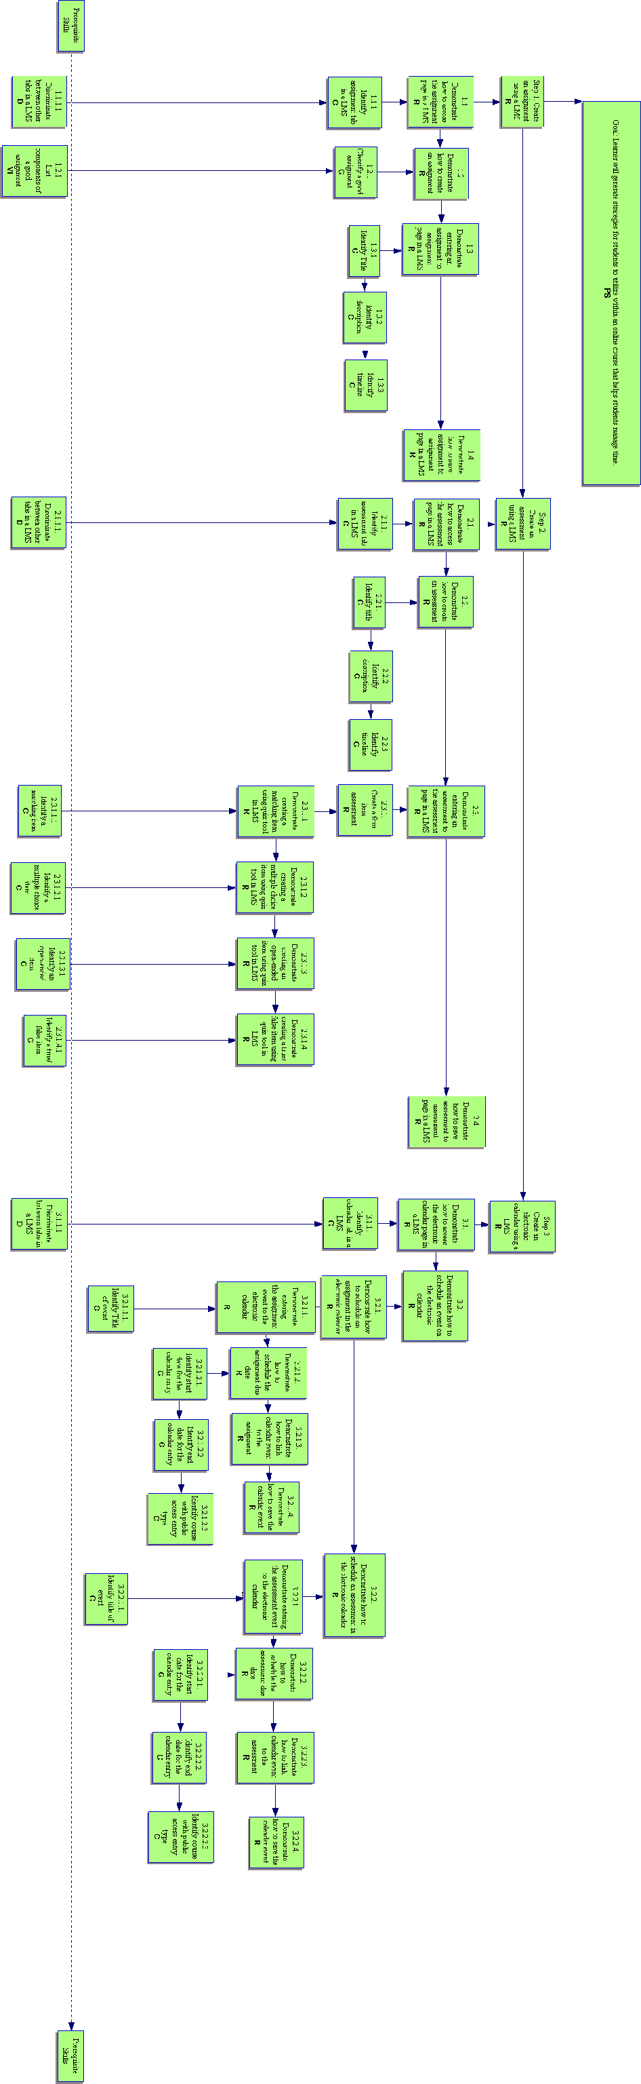
Appendix A
Task Analysis
Appendix B
Assessment Book

ROC’D
Rapid Online Course Development Project

Assessment Book

Checklists and Assessment Questions
For the Time Management Instructional Module:
Creating an Assignment
Creating and Assessment
Creating an Electronic Calendar

Use this book along with the instructional module.

Designed by:
Erin Gunter
Kevin Wicker
Assessment Items
Pre-Test (Assessment tools for Entry Behaviors):

1. Do you know how to login to a Blackboard LMS account?
____ Y or ____ N

2. What are the qualities of a good assignment?
A.
B.
C.
D.

3. What are the qualities of a good assessment?

4. What is an open-ended item?

5. What is a multiple choice item?

6. What is a matching item?

7. What is a true/false item?
Assessment Checklists and Questions that Accompany the
Creating an Assignment Video

  - Demonstrate how to access the assignment page
___ Log on the Blackboard Account
___ Access the Course
___ Make sure you are in the build tab
___ Locate the course tools navigation bar
___ Click on the Assignment link
1.1.1 Find the assignment tab by placing a checkmark close to the tab.
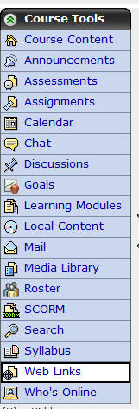

  - Click on the create assignment link within the instructional video.

    - Classify the following components into whether or not they are good components for an online assignment.
Timeline
Description
Multiple Ways to complete the assignment
Title
Unlimited submissions

  - Demonstrate entering an assignment to access the assignment page
___ Identify a title in the title box
___ Identify a description in the description box
___ Identify a timeline for the assignment using the date and time boxes

    - Identify title – Circle the title box in the following screen shot and write the title “Module One” in the title box.
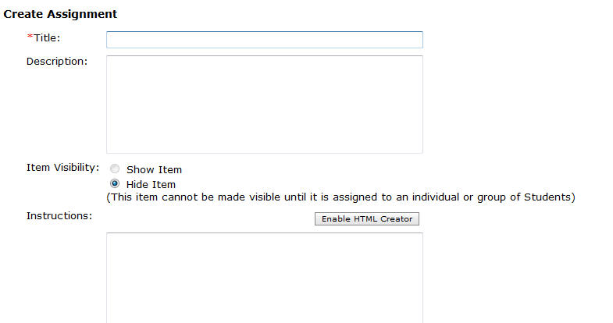
    - Identify description – Circle the description box in the following screen shot and write the description “Reading and Summary Assignment” in the description box.
    - Identify timeline – Circle the due date box and due date time box in the following screen shot and write the following due date and due date time “12/10/2008” and “12:00 PM” in the appropriate boxes.
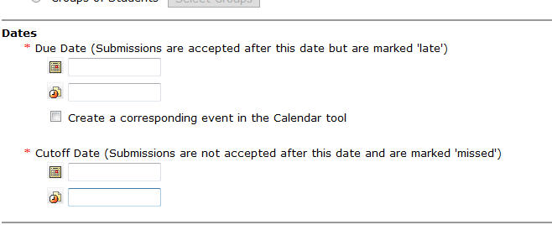

  - Click on the save button at the bottom of the page within the instructional video.

Assessment Checklists and Questions that Accompany the
Creating an Assessment Video

  - Demonstrate how to access the assessment page
___ Log on the Blackboard Account
___ Access the Course
___ Make sure you are in the build tab
___ Locate the course tools navigation bar
___ Click on the Assessment link

2.1.1 Find the assessment tab by placing a checkmark close to the tab.

  - Click on the create assessment link within the instructional video.

    - Identify title – Circle the title box in the following screen shot and write the title “Module 4” in the title box.
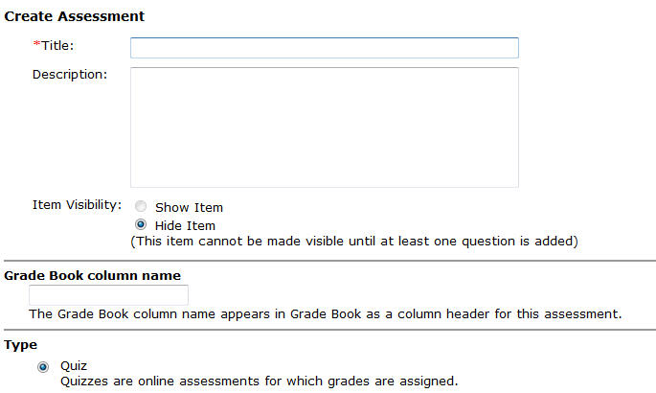

    - Identify description – Circle the description box in the following screen shot and write the description “A four-item assessment.” in the description box.
    - Identify timeline – Circle the due date box and due date time box in the following screen shot and write the following due date and due date time “12/10/2008” and “5:00 PM” in the appropriate boxes.

Circle the cutoff date box and cutoff date time box in the following screen shot and write the following cutoff date and cutoff date time “12/12/2008” and “5:00 PM” in the appropriate boxes.

  - Click on the save and add questions button at the bottom of the page within the instructional video.

    - Click on the create question button within the instructional video.

      - Demonstrate creating a matching item using the quiz tool
___ Click on the matching link in the drop down menu
___ Fill in the title
___ Fill in the matching statements
___ Fill in the matching answers
___ Save the matching item

      - Demonstrate creating a multiple choice item using the quiz tool
___ Click on the multiple choice link in the drop down menu
___ Fill in the title
___ Fill in the multiple choice question
___ Fill in the multiple choice answers
___ Select the correct multiple choice answer
___ Save the multiple choice item

      - Demonstrate creating an open-ended item using the quiz tool
___ Click on the short answer link in the drop down menu
___ Fill in the title
___ Fill in the open-ended question
___ Fill in the open-ended answer
___ Save the open-ended item

      - Demonstrate creating a true/false item using the quiz tool
___ Click on the true/false link in the drop down menu
___ Fill in the title
___ Fill in the true/false statement
___ Fill in the whether the statement is true or false
___ Save the true/false item

  - Demonstrate how to save an assessment in the assessment page
___ Finish creating all the questions
___ Save all the questions
___ Select show assessment in assessment page

Assessment Checklists and Questions that Accompany the
Creating an Electronic Calendar

  - Demonstrate how to access the electronic calendar page
___ Log on the Blackboard Account
___ Access the Course
___ Make sure you are in the build tab
___ Locate the course tools navigation bar
___ Click on the Calendar link

3.1.1 Find the calendar tab by placing a checkmark close to the tab.

  - Click on the add entry link within the instructional video.

Assessment Checklists and Questions that Accompany the
Creating an Assignment Entry in the Electronic Calendar

      - Click on the add entry button within the instructional video.

        - Identify title – Circle the title box in the following screen shot and write the title “Module 3 Team Activity” in the title box.
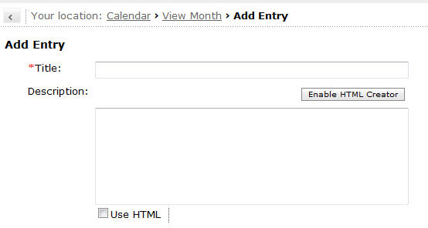
      - Schedule an assignment due date on the electronic calendar.
___ Identify the start date
___ Identify the end date
___ Identify course with public access entry type

        - Identify Start Date for assignment calendar entry - Circle the start date box and the start date time box and write the following start date and start date time in the appropriate boxes, “12/4/2008”and “12:00 PM” for the assignment.
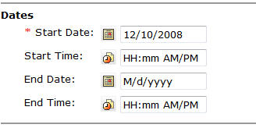
        - Identify End Date for assignment calendar entry - Circle the end date box and the start end time box and write the following end date and end date time in the appropriate boxes, “12/10/2008”and “11:59 PM” for the assignment.

        - Identify course with public access entry type - Circling the course and public entry types.
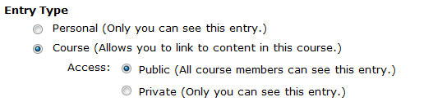

      - Demonstrate creating a hyperlink between the calendar entry and the assignment in the assignment page.
___ Click on More Options
___ Click on the Add Content Link
___ Select Assignments
___ Select the Assignment “Module 3 Team Activity”
___ Click Add Selected

      - Click on the save button within the instructional video.

Assessment Checklists and Questions that Accompany the
Creating an Assessment Entry in the Electronic Calendar

      - Click on the add entry button within the instructional video.

        - Identify title – Circle the title box in the following screen shot and write the title “Module 3 Quiz” in the title box.
      - Schedule an assignment due date on the electronic calendar.
___ Identify the start date
___ Identify the end date
___ Identify course with public access entry type

        - Identify Start Date for assessment calendar entry - Circle the start date box and the start date time box and write the following start date and start date time in the appropriate boxes, “12/3/2008”and “8:00 PM” for the assessment.
        - Identify End Date for assessment calendar entry - Circle the end date box and the start end time box and write the following end date and end date time in the appropriate boxes, “12/4/2008”and “8:00 PM” for the assessment.

        - Identify course with public access entry type - Circling the course and public entry types.

      - Demonstrate creating a hyperlink between the calendar entry and the assignment in the assignment page.
___ Click on More Options
___ Click on the Add Content Link
___ Select Assessments
___ Select the Assessment “Module 3 Quiz”
___ Click Add Selected

      - Click on the save button within the instructional video.
Final Assessment (Post-Assessment of the Terminal Objective)

At this point you should have completed the instructional module and all the assessments for each of the videos. Your task at this time is to create an assignment, and assessment, and an electronic calendar using your Blackboard Vista LMS account using the following checklist below to track your progress.

Create an assignment using a LMS with information from a pre-existing assignment that you have developed.

___ Demonstrate how to access the assignment page in a LMS
___ Identify the Assignment tab in a LMS
___ Demonstrate how to create an assignment
___ Classify a good assignment
___ Demonstrate entering an assignment to the assignment page in a LMS
___ Identify the title
___ Identify the description
___ Identify a timeline
___ Demonstrate how to save an assignment to assignment page in a LMS

Create an assessment using a LMS with information from a pre-existing assessment.

___ Demonstrate how to access the assessment page in a LMS
___ Identify the assessment tab in a LMS
___ Demonstrate how to create an assessment
___ Identify a title for the assessment
___ Identify a description for the assessment
___ Identify a timeline for the assessment
___ Demonstrate entering an assessment to the assessment page in a LMS
___ Create a four-item assessment
___ Demonstrate creating a matching item using the quiz tool
___ Demonstrate creating a multiple choice item using the quiz tool
___ Demonstrate creating an open-ended item using the quiz tool
___ Demonstrate creating a true/false item using the quiz tool
___ Demonstrate how to save an assessment to the assessment page in a LMS

Create an electronic calendar using a LMS.

___ Demonstrate how to access the electronic calendar page in a LMS
___ Identify the calendar tab in a LMS
___ Demonstrate how to schedule an event on the electronic calendar
___ Demonstrate how to schedule an assignment in the electronic calendar
___ Demonstrate entering the assignment event to the electronic calendar
___ Identify a title for the event
___Demonstrate how to schedule the assignment due date
___ Identify start date for the calendar entry
___ Identify end date for the calendar entry
___ Identify course with public access entry type
___ Demonstrate how to link a calendar event to the assignment
___ Demonstrate how to save the calendar event
___ Demonstrate how to schedule an assessment in the electronic calendar
___ Demonstrate entering the assessment event to the electronic calendar
___ Identify a title for the event
___Demonstrate how to schedule the assessment due date
___ Identify start date for the calendar entry
___ Identify end date for the calendar entry
___ Identify course with public access entry type
___ Demonstrate how to link a calendar event to the assessment
___ Demonstrate how to save the calendar event

One-on-One Evaluation Objective Analysis Table
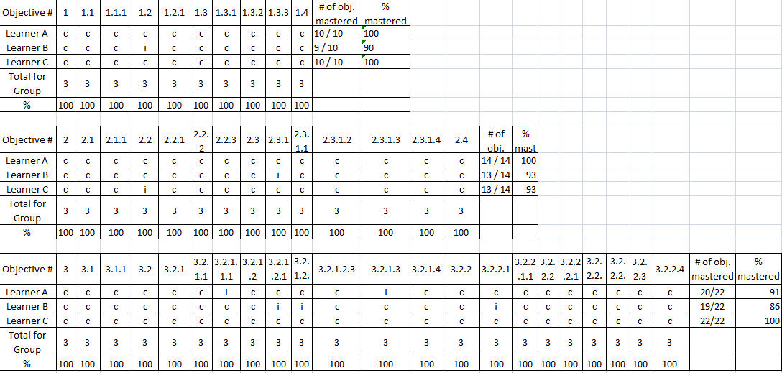
The table below shows the objectives for this instructional module. The learner either completed the objectives assessment tasks correctly or incorrectly. The (c) represents a correct answer. The (i) represents an incorrect answer. Mastery of the objectives is defined as correctly answering and completing the assessment tasks presented to the learner throughout the module.

Small Group Evaluation Objective Analysis Table
The table below shows the objectives for this instructional module. The learner either completed the objectives assessment tasks correctly or incorrectly. The (c) represents a correct answer. The (i) represents an incorrect answer. Mastery of the objectives is defined as correctly answering and completing the assessment tasks presented to the learner throughout the module.
